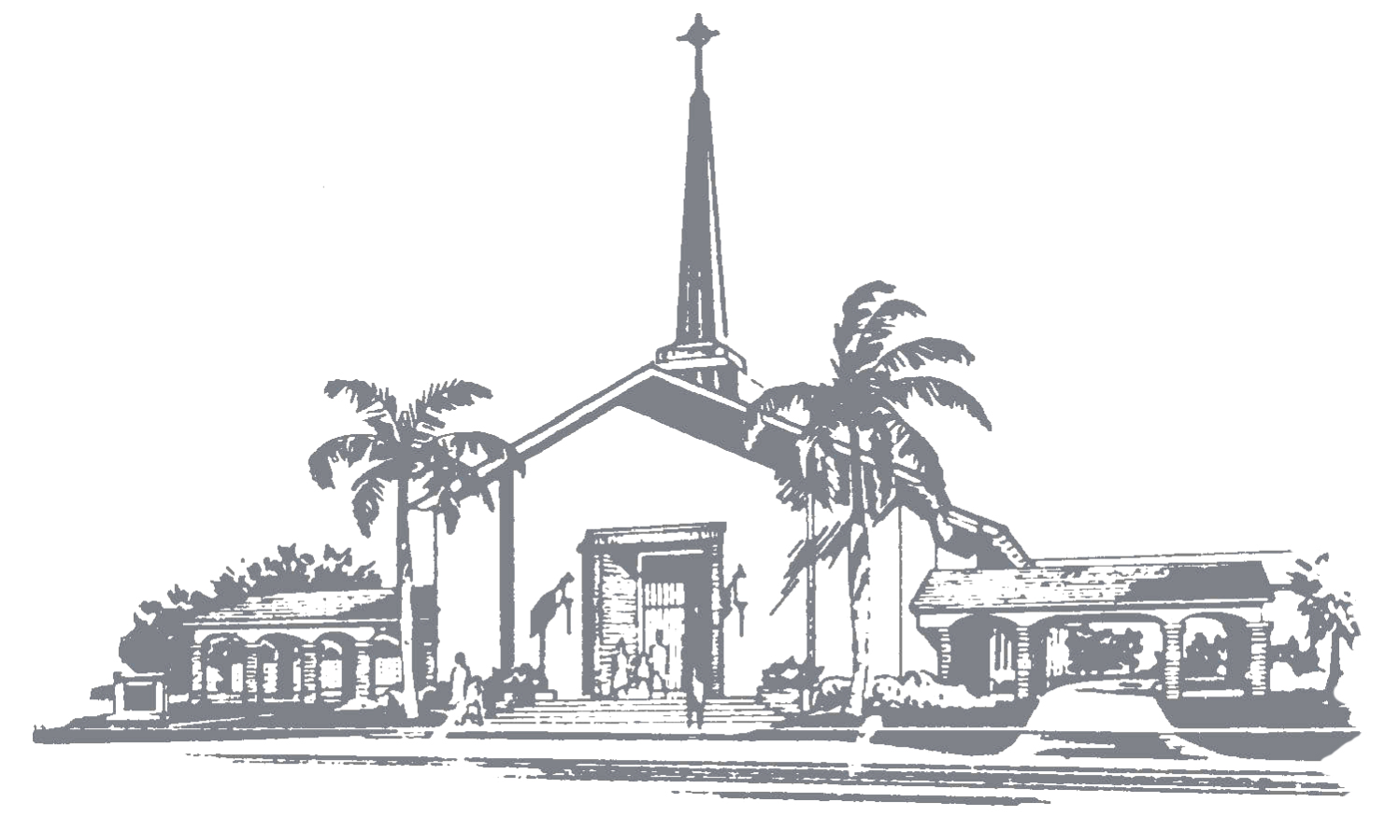
Community Presbyterian Church
1920 SE Fourth Street
Deerfield Beach, FL 33441
Telephone: 954-427-0222
Email: communitych1920@gmail.com
www.communitypreschurch.org

Wedding Information
We believe that marriage is a covenant between a man and a woman who, before God, make a lifelong commitment to one another. In our wedding ceremonies, we rejoice that marriage is a gift given by God, blessed by Jesus Christ and sustained by the Holy Spirit. The wedding ceremony marks the beginning of a union between the husband and wife and Christ, and celebrates God’s plan for marriage.

A minister can be provided by Community Presbyterian Church, which includes premarital counseling and the rehearsal.
If you wish to use your own minister, that request will be evaluated by our minister. All outside ministers must be ordained by a recognized Christian church body and will need to provide proof of licensing and/or ordination from a recognized denomination. A copy of a current letter or ministerial identification card is acceptable.
Piano may be played by outside musicians. Our Organ may not be played by outside musicians, except with permission from our pastor. If you desire to have an organist, please contact the church office at 954-427-0222.
In order to secure a date each couple must return a signed copy of this contract and pay
a non-refundable deposit to hold your date of $500.00.

This deposit is refundable up to 3 months from the date of the wedding.

All fees as outlined below need to be paid to Community Presbyterian Church and given by cash or check to the Church Administrative Assistant no later than 30 days prior to the wedding rehearsal.

Wedding parties will have access to the church for a total of 5 hours:
- 1 hour for the rehearsal
- 2 hours prior to the wedding (church will be unlocked)
- 1 hour for the wedding
- 1 hour after the ceremony for pictures

Refundable Fees:
A combined Security Damage /Allotted Time Overage Deposit (Late Fee) for wedding in amount of: $400.00 ($200.00 security damage and $200.00 time overage)

Secutity Damage Fee WILL BE REFUNDED 15 DAYS AFTER THE EVENT, SO LONG AS THERE ARE NO DAMAGES.

LATE FEE WILL BE REFUNDED 15 DAYS AFTER THE EVENT, SO LONG AS /REHEARSAL BEGAN ON TIME & NOT TO EXCEED 1 HOUR, WEDDING DAY, START ON TIME / NOT TO EXCEED 4 HOURS.


Weddings Fees & Options
Sanctuary $900 Chapel $600
Church Coordinator $250*
Custodian $200*
Sound Technician $200
Musician $300
Minister $500
Briggs Hall rental $500
Refundable Fees (see above) $400*

* These fees are required and part of every wedding event

No church decorations may be moved (especially during Christmas & Easter season), although wedding parties may decorate to their liking as approved by the Church Coordinator. Extreme care must be taken in decorating to protect and preserve the historic beauty of the church, the pews and other furnishings.
Following the service, no birdseed, balloons, rice or confetti allowed to be thrown inside or outside the church. Also no live flowers are to be thrown in the sanctuary.
Please be advised that the church's Organ, while a centerpiece of our wedding and music ministry, is old and requires constant care and maintenance. The Church cannot guarantee the use of the Organ for any event. The pastor must approve usage. In the event the Organ is not operable, the Church will strive to give reasonable notice prior to the event to the extent reasonably possible.

Community Presbyterian Church reserves the right to schedule overlapping events, so long as each event does not jeopardize the integrity of the other. Smoking is not allowed on the Community Presbyterian Church campus and food/drinks are not allowed in the Sanctuary or Chapel.

Contract
We, the undersigned, understand the wedding information of the Community Presbyterian Church of Deerfield Beach and agree to abide faithfully by them.

Bride: _________________________ Signature: _________________________
Groom: _________________________ Signature: ________________________
Date: _________________________
Date and Time of the Rehearsal: _______________________________________
Date and Time of the Wedding: _______________________________________

