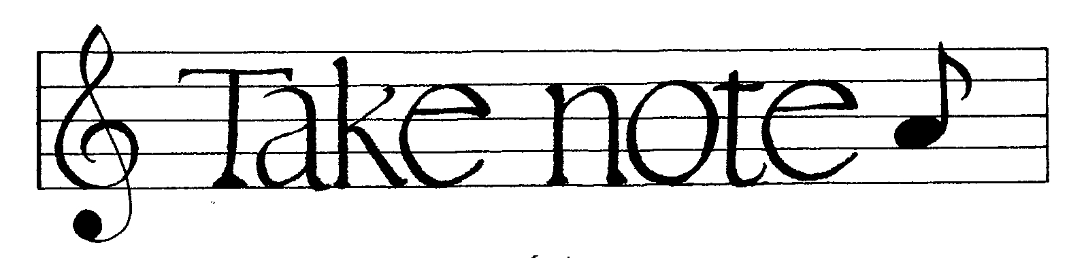

Community Presbyterian Choir Newsletter

FROM THE TOP!
There’s a lot going on within the next couple of weeks. Top of the list is our new hymnal dedication, scheduled for February 26. In order to get ready for this special service, I need volunteers for this coming Saturday, Feb. 18, and next Saturday, Feb. 25. We are meeting at 2:00 in the afternoon both days. If you are able to help, please let me know. Many hands will make quick work of this project.
On Sat. Feb 18, our goal is to remove the bar code stickers from the back of each hymnal, and then put dedicatory bookplates in the front cover and platinum donor bookplates inside the back cover. Big thanks to Gerda and Gloria for their help this past Saturday!
On Sat. Feb 25, we will finish with the bookplates, and install the new hymnals in their places around the church and remove the 1955 hymnals to the boxes that the Glory to God hymnals came in.
There are no concrete plans for disposing of the old hymnals. We will keep a few, and are looking for churches within our Presbytery that might have a need for them, but that likelihood is slim because of the advanced age and poor quality of many of our hymnals. We will probably let our congregation take one home if they would like to.
We will not be singing an anthem on Feb. 26, but instead will sing several hymns with the congregation from the new hymnal. You will also be asked to read some scriptures as part of the program. If you are willing to read a brief passage, please let me know, otherwise, I may “volunteer” you!
HOPE TO SEE YOU
THIS COMING SATURDAY AT 2:00!
Thanks! - Sabrina

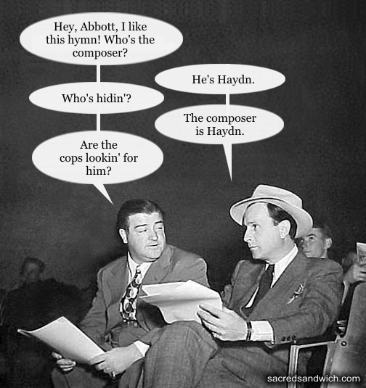

CALENDAR
Wed. Feb 15 7:00 Choir rehearsal, no 6:15
Sun. Feb 19 9:50 Meet in hallway for prayer.
Special Music, but we are singing introit, hymns and responses
11:15 After service rehearsal

Wed. Feb 22 7:00 Choir rehearsal, no 6:15

Sun. Feb 26 9:15 Hymnal Dedication Service
11:15 After service rehearsal

Tues. Feb 28 6:15 Ladies sectional rehearsal
7:00 All rehearsal

Wed. March 1 7:00 (?) Ash Wednesday service

